Week 03

**Question 1:**

**Write a program to read two integer values and print true if both the numbers end with the same digit, otherwise print false. Example: If 698 and 768 are given, program should print true as they both end with 8.**

**Program:** 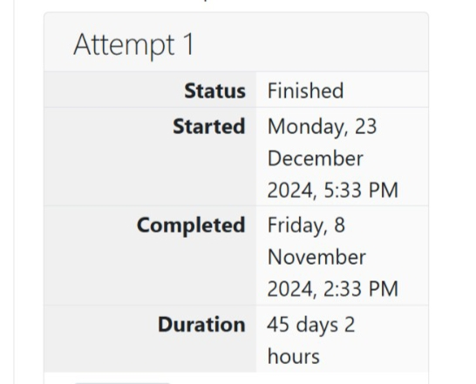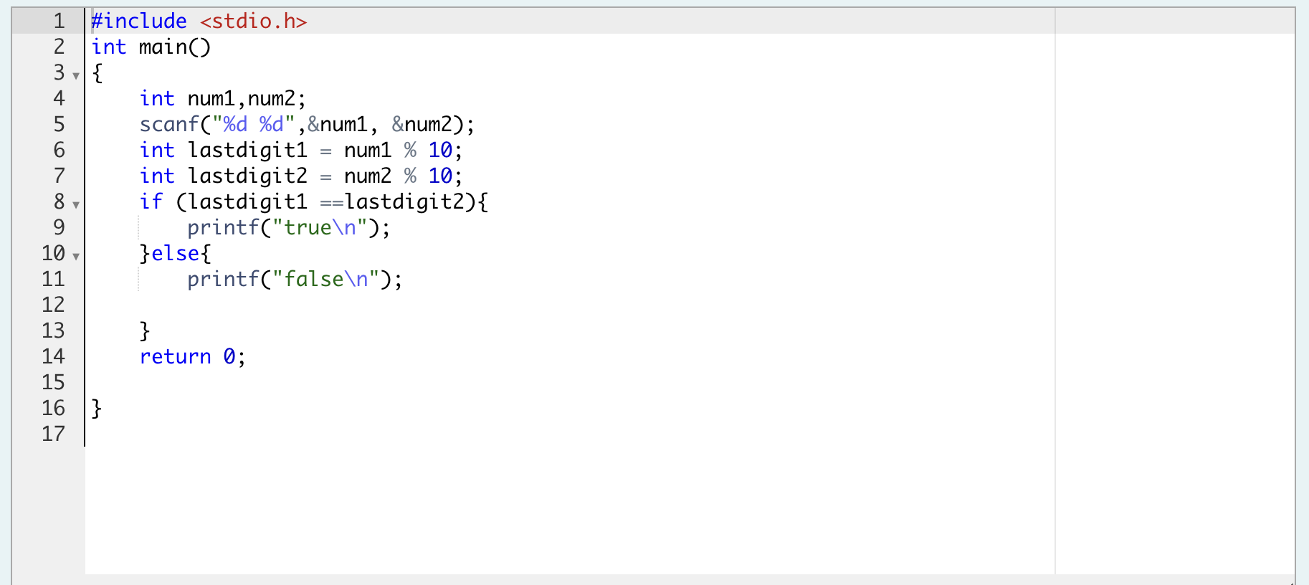

**Output:**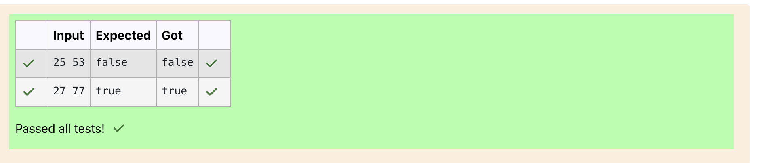

**Question 2:**

**Given an integer, *n*, perform the following conditional actions:**

**· If *n* is odd, print Weird**

**· If *n* is even and in the inclusive range of *2* to *5*, print *Not Weird***

**· If *n* is even and in the inclusive range of *6* to *20*, print *Weird***

**· If *n* is even and greater than *20*, print *Not Weird***

**Program:** 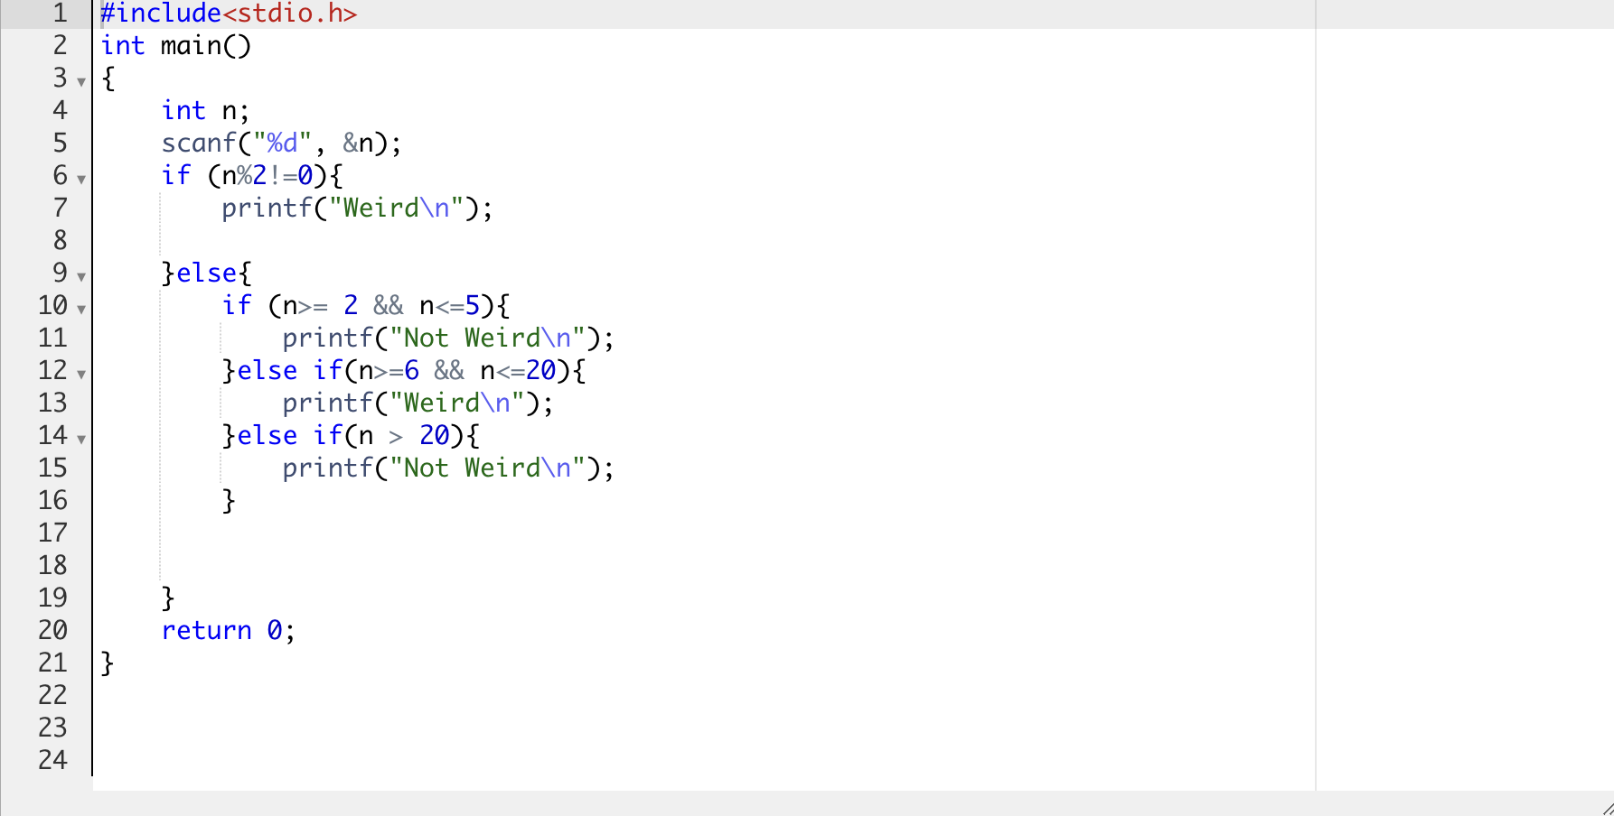

**Output:**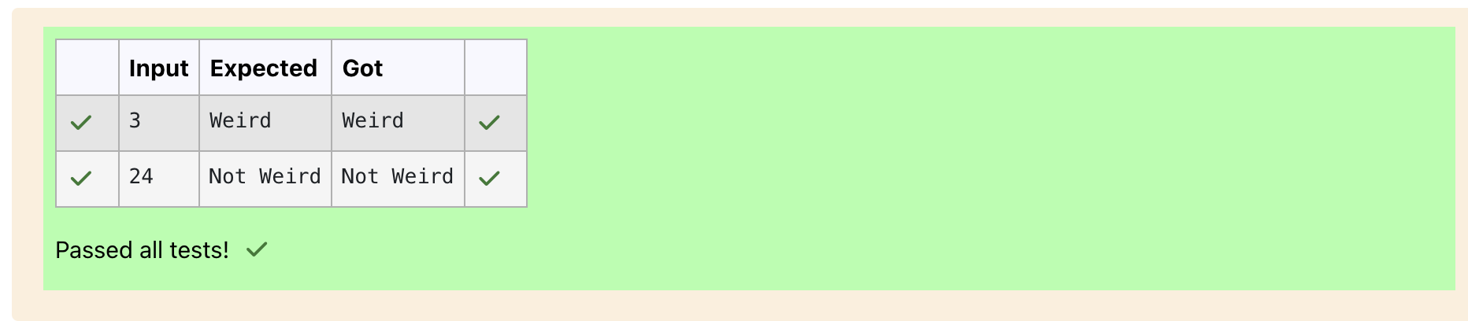

**Question 3:**

**Three numbers form a Pythagorean triple if the sum of squares of two numbers is equal to the square of the third. For example, 3, 5 and 4 form a Pythagorean triple, since 3*3 + 4*4 = 25 = 5*5 You are given three integers, a, b, and c. They need not be given in increasing order. If they form a Pythagorean triple, then print "yes", otherwise, print "no". Please note that the output message is in small letters.**

**Program:** 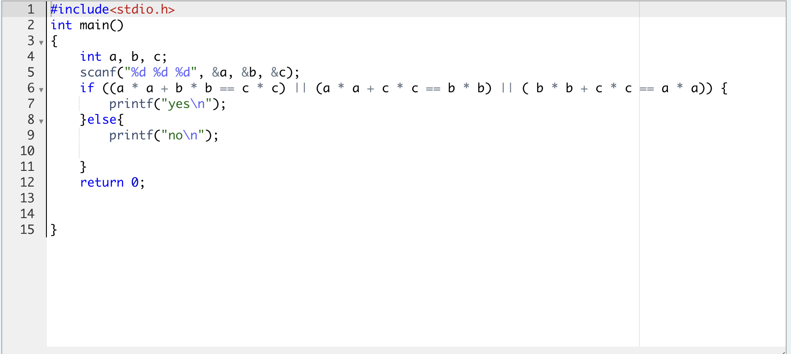

**Output:** 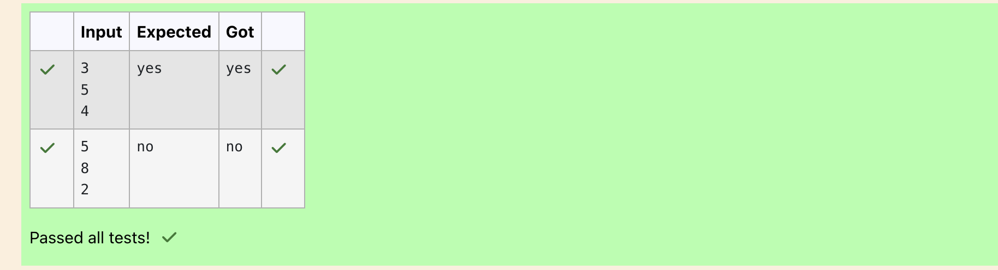

**Question 4:**

**Write a program that determines the name of a shape from its number of sides. Read the number of sides from the user and then report the appropriate name as part of a meaningful message. Your program should support shapes with anywhere from 3 up to (and including) 10 sides. If a number of sides outside of this range is entered then your program should display an appropriate error message.**

**Program:** 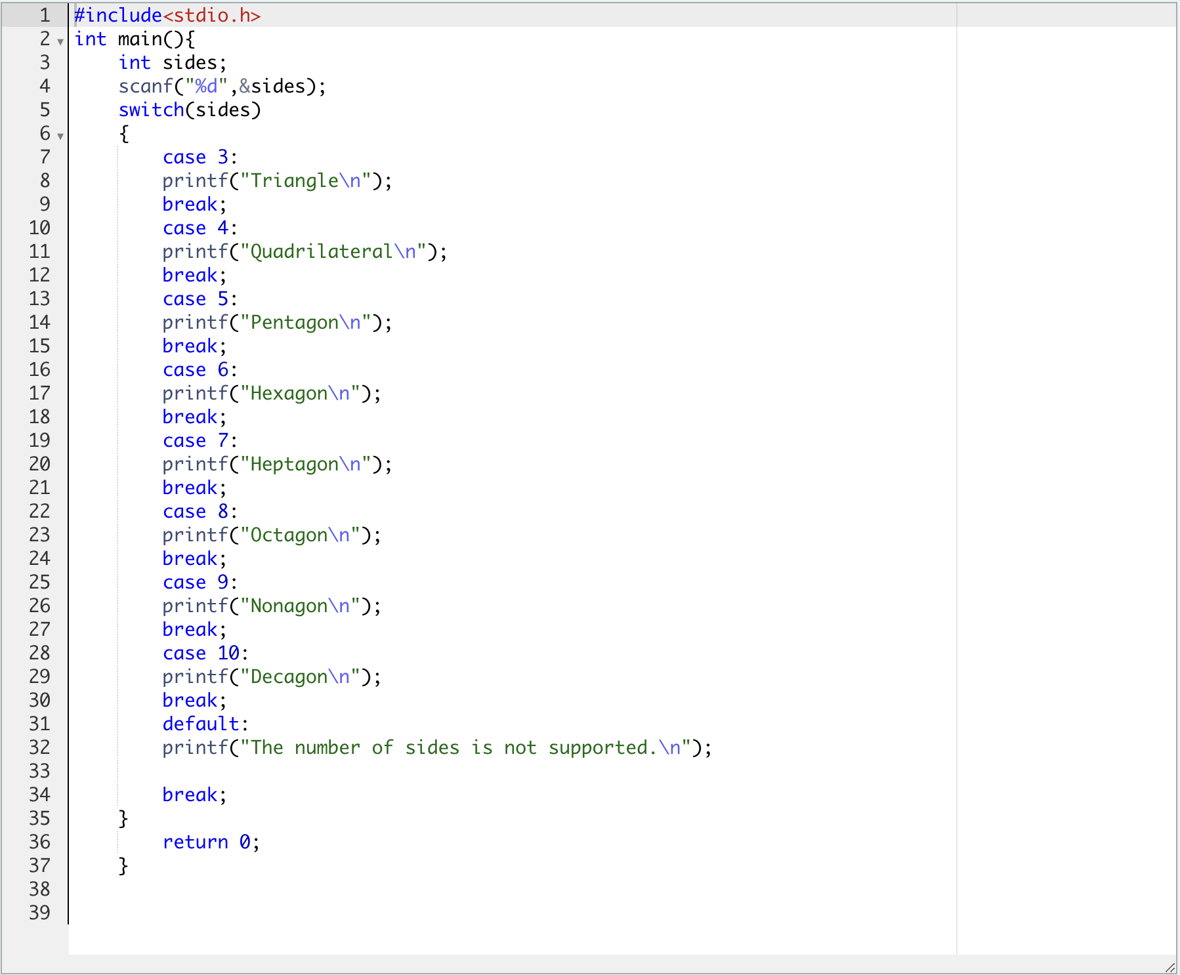

**Output:**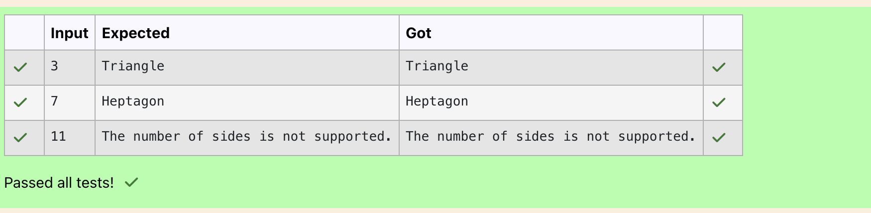

**Question 5:**

**The Chinese zodiac assigns animals to years in a 12-year cycle. One 12-year cycle is shown in the table below. The pattern repeats from there, with 2012 being another year of the Dragon, and 1999 being another year of the Hare.**

**2000-Dragon 2001-Snake 2002-Horse 2003-Sheep 2004-Monkey 2005-Rooster 2006-Dog 2007-Pig 2008-Rat 2009-Ox 2010-Tiger 2011-Hare**

**Write a program that reads a year from the user and displays the animal associated with that year. Your program should work correctly for any year greater than or equal to zero, not just the ones listed in the table.**

**Program:** 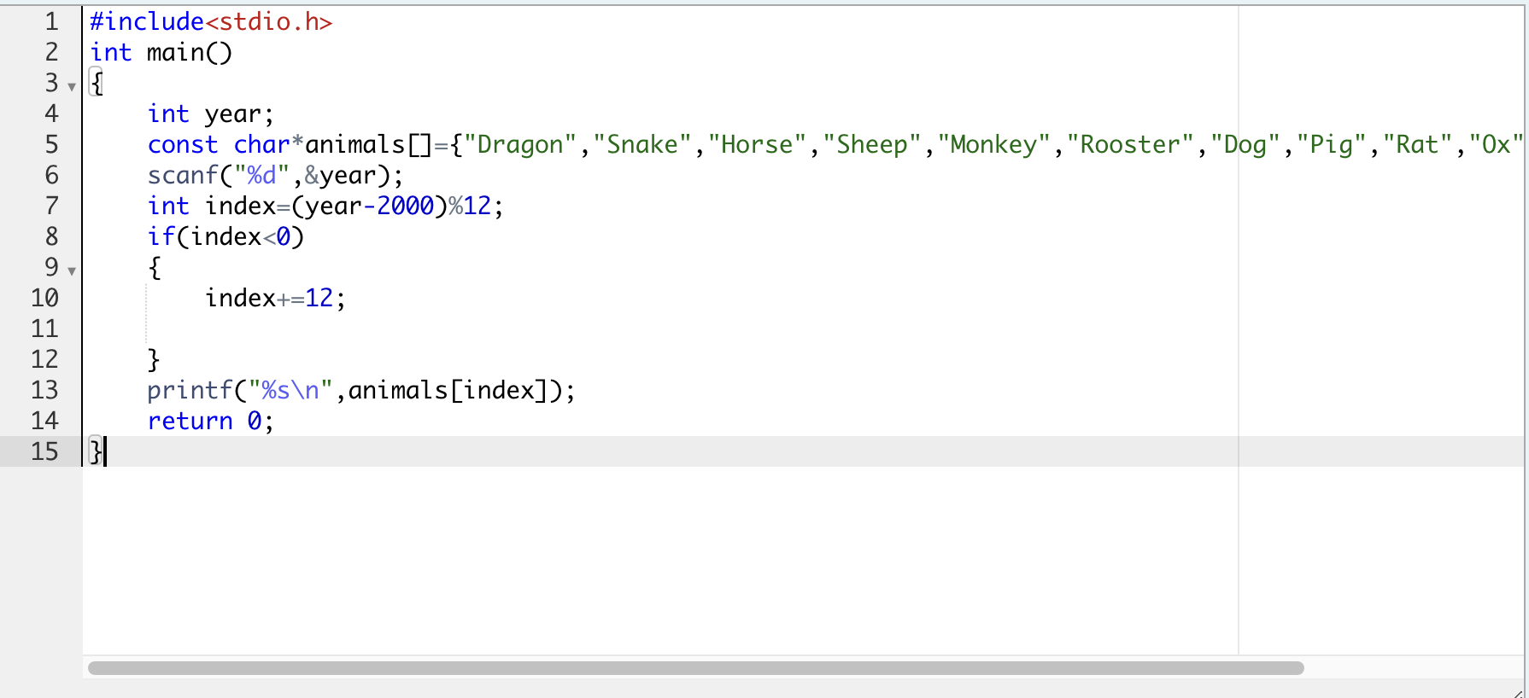

**Output:**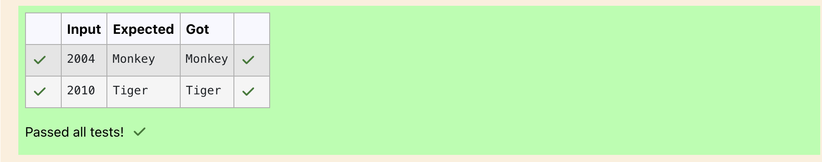

**Question 6:**

**Positions on a chess board are identiﬁed by a letter and a number. The letter identiﬁes the column, while the number identiﬁes the row, as shown below:**

**Write a program that reads a position from the user. Use an if statement to determine if the column begins with a black square or a white square. Then use modular arithmetic to report the color of the square in that row. For example, if the user enters a1 then your program should report that the square is black. If the user enters d5 then your program should report that the square is white. Your program may assume that a valid position will always be entered. It does not need to perform any error checking.**

**Program:** 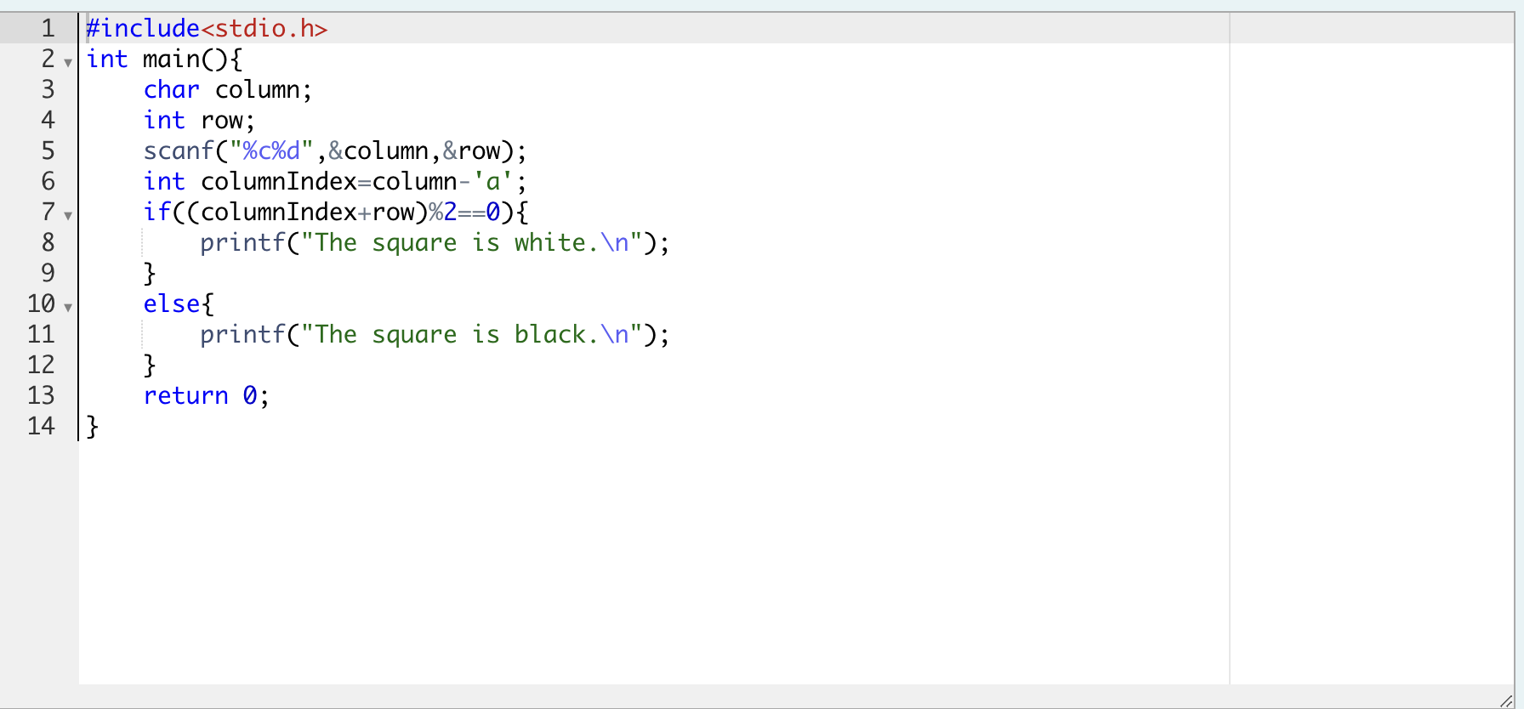

**Output:**